

# Boonchoo Tour and Travel.

E-mail: john@boonchootourandtravel.com.au

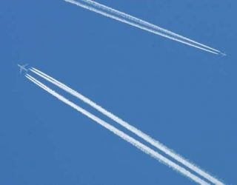

### Boonchoo Tour and Travel

## **Club/School/Community Group Rewards Program**

16 Beauford Ave

Bell Post Hill

Vic, 3215

Phone: 03 42080225

Mobile 0429646924

**BOONCHOO TOUR & TRAVEL** and **Café Boonchoo Thai** are very pleases to have Rollins Primary School as a member of our Community Rewards Program.

John & Chetsuda McKenzie.

 

Boonchoo Tour and Travel is proud to introduce to Rollins Primary School our community Rewards Program. Boonchoo Travel will donate to the school for every booking made by a member, or their family or friends. For a domestic booking, Rollins can receive up to $50. For an International booking, up to $75 per person can be earned. The final amount will depend upon each individual booking.

As a family from Rollins, all you need to do is, firstly get a quote for your travel/holiday needs. If you are happy with our service and prices, then make a booking. Once this booking has been confirmed and paid, we will donate to the school the appropriate amount. Boonchoo will ensure that the school is aware which Family has assisted the club in fundraising.

Boonchoo’s prices are aimed at competing with those you may find on the internet, but with personalised service, aimed at making your holiday/trip as easy as possible.